Date:14-12-23

Python Assignment

**Today’s topics**: Operators, Loops, List, List slicing, Break, Continue, Pass, is not is, Match case, Nested loop.

Operators:

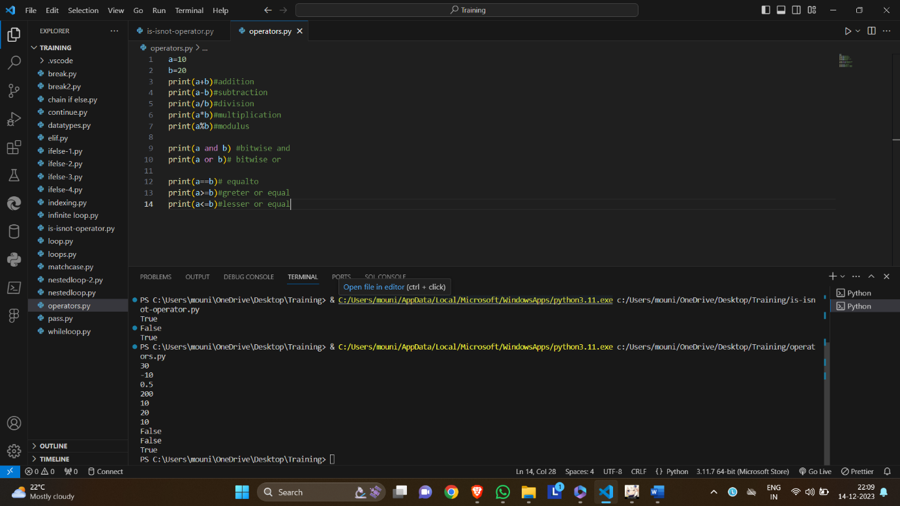

Loops:

List slicing:

BREAK, CONTINUE, PASS:

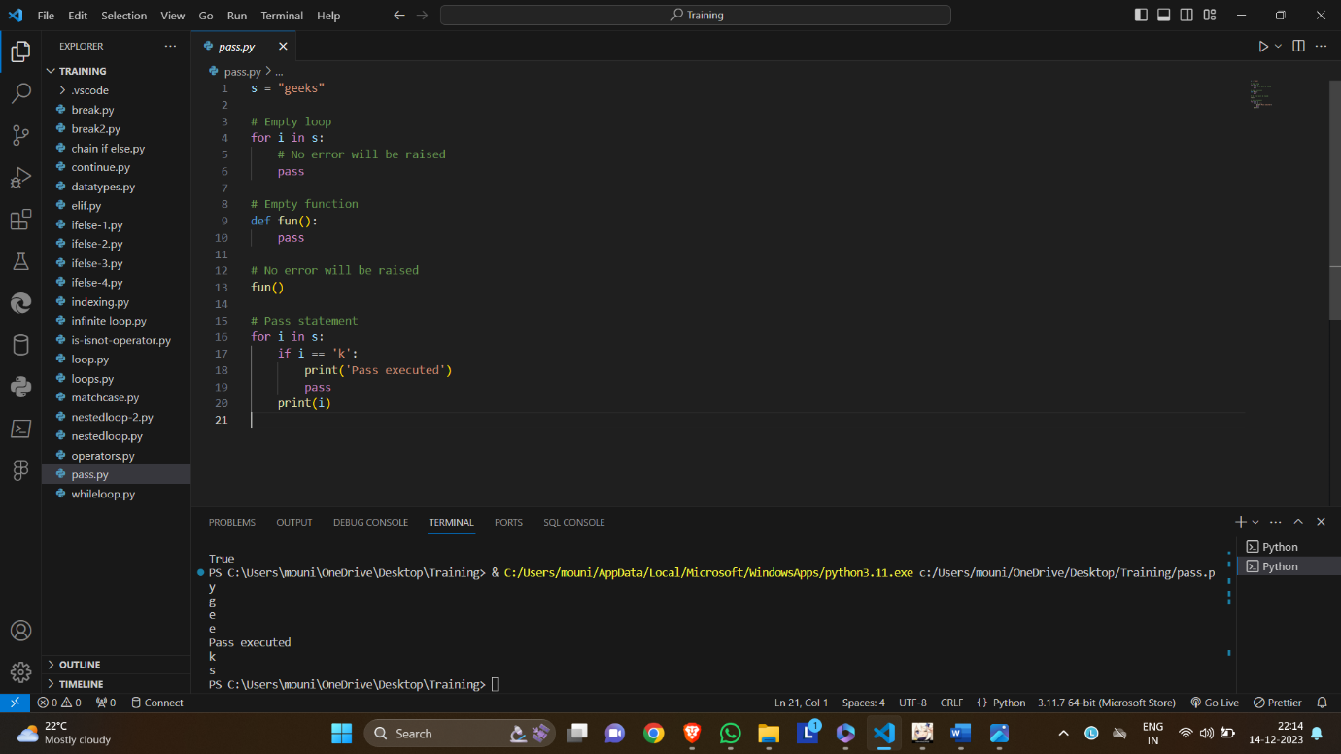

IS not,IS:

Nested loop:

Match case:

